Cyber Security

Name : Zannat Hossain Tamim

Class Number : 05

Date : 21 Sep 2024

# Reconnaissance:

- OSINT – Open Source Intelligence

Pentest Methodology

- https://www.virustotal.com/gui/ check is there any virus in crack file for any link must first try this link and then click the link

- https://app.any.run/ virus check for file

- https://leakpeek.com/ check, is your data public?

- For a picture, first check property

- How to create a Share Folder in kali Linux See assignment

o First turnoff the virtual machine then start again

o Cd /media/sf_JU sf mean shared file //terminal (use TAB button)

o Store ch9 file in shared folder manually

o Disk file check testdisk ch9 InteladvanceFAT32 listfileif there is a red file then go this file using cursor and type C and again C… file will be store in JU folderconvert file into ZIP then extract allcheck properties of this picture

o Terminal cd /media/sf_JU/Files/revendications/Pictures file location

Type exiftool 1000000000.jpg picture name show all details about this picture

https://www.gps-coordinates.net/ add coordinate

┌──(root㉿kali)-[~]

└─$ sudo -i

[sudo] password for root:

┌──(root㉿kali)-[~]

└─# cd /media/sf_Share

┌──(root㉿kali)-[/media/sf_Share]

└─# ls

ch9

┌──(root㉿kali)-[/media/sf_Share]

└─# testdisk ch9

TestDisk 7.2, Data Recovery Utility, February 2024

Christophe GRENIER <grenier@cgsecurity.org>

https://www.cgsecurity.org

┌──(root㉿kali)-[~]

└─# cd /media/sf_Share/Files/revendications/Pictures (Use TAB)

┌──(root㉿kali)-[/media/sf_Share/Files/revendications/Pictures]

└─# exiftool 1000000000000CC000000990038D2A62.jpg

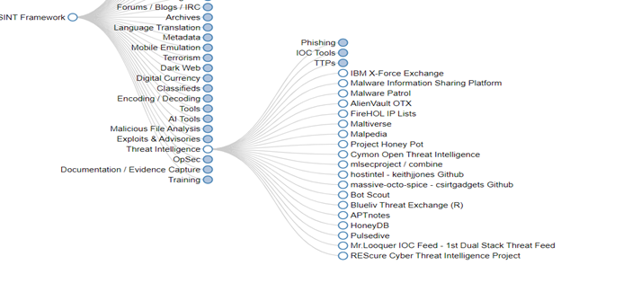

- https://osintframework.com/ Check fast

- Assignment :

- Exodus mobile aps: for check any aps permission. Very important aps

- https://osintleak.com/dashboard : for user all details

- ?intitle:index.of? pdf hacking for download any file/videos/ or goto https://www.dorkgpt.com/

site:juniv.edu filetype:doc

- dorkgpt. Com theke j kono 5 ta search er assignment

- https://www.exploit-db.com/google-hacking-database Exploit database

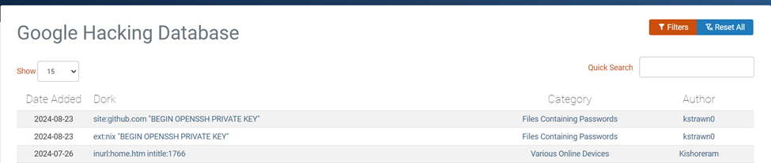

- https://polyswarm.io/

Scan for big data/file

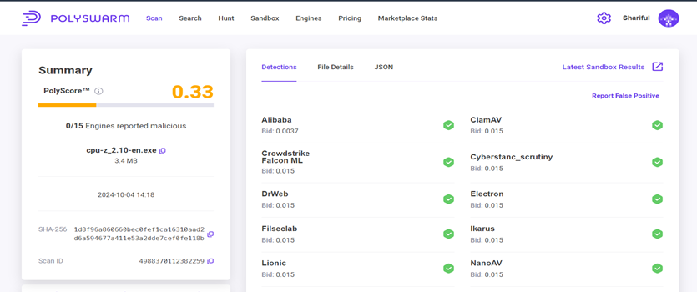

- <https://www.hybrid-analysis.com/>

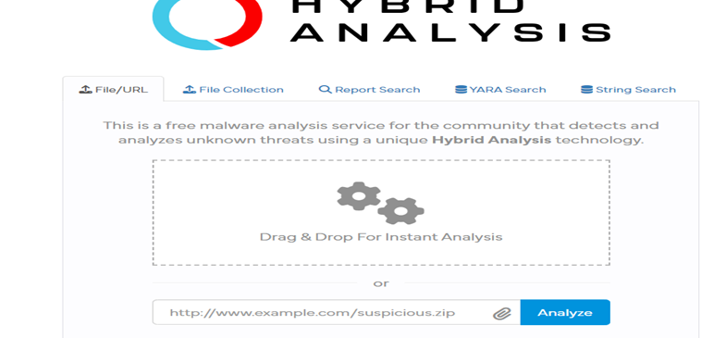

Free automated malware analysis

- https://urlscan.io/

Domain and IP information and all details about any URL

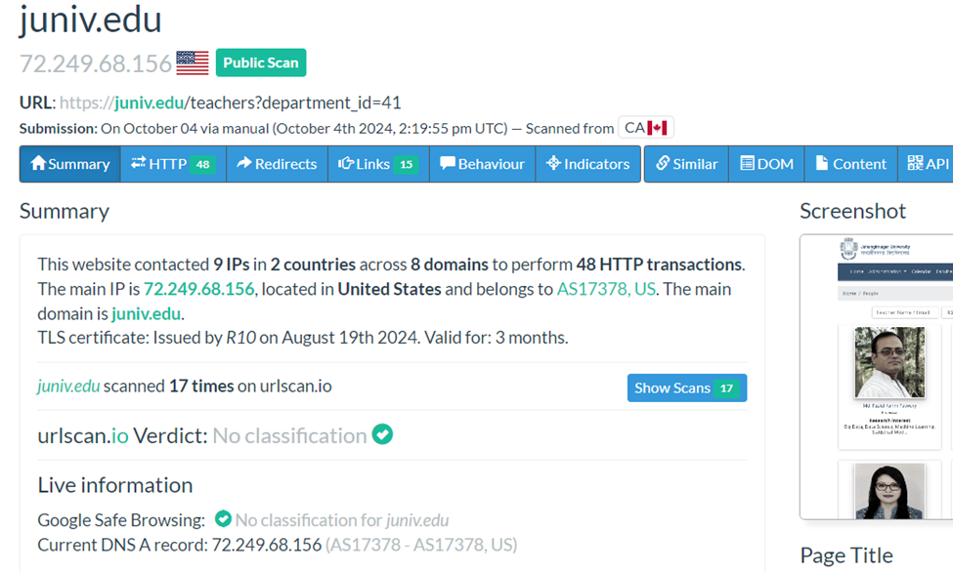

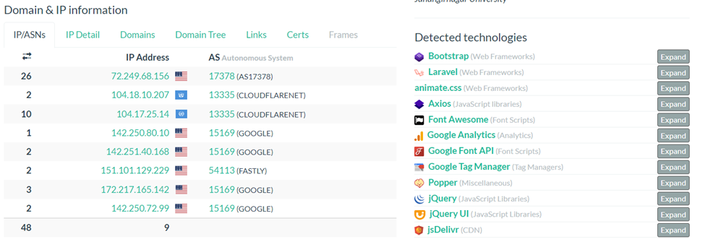

- https://talosintelligence.com/

- https://urlhaus.abuse.ch/browse/

List of all malware website, anyone can submit a website as a malware.

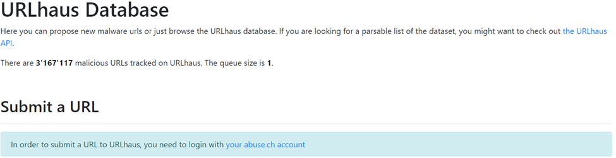

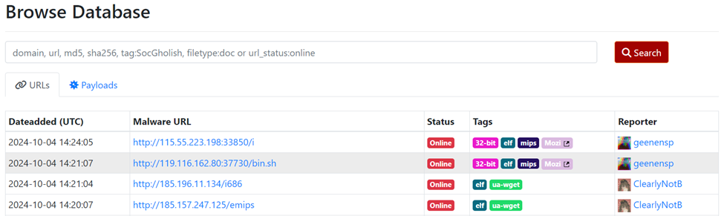

-

- Assignment: world wide CC tv access

-

- https://abuse.ch/ check 6 category assignment

# Link from Arabi Sir:

https://polyswarm.network/scan

https://metadefenderopswat.com/

https://analyze.intezer.com/

https://www.hybrid-analysis.com/

https://app.any.run/

https://tria.ge/submit/file

OSINT Tools Collections #1

OSRFramework: https://lnkd.in/dY2TZARX

OSINTLeaks: https://osintleak.com/

ChatGPT like web:

1. Poe

2. https://claude.ai/new

3.

Just search and see:

• intitle:"webcamxp 5"

• site:juniv.edu filetype:pdf

• http://insecam.org/en/byrating/

•